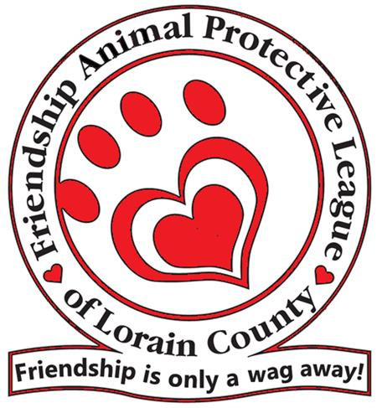
SHOP AND ADOPT 2019
Saturday, August 31, 2019 11am-3pm
Market Square at Crocker Park
Westlake, OH 44145
VENDOR REGISTRATION
Vendor Organization:
Contact Name:
Address:
Business Phone: Cell Phone:
Email:
Website:

Each Booth Space will be a 10’ wide x 8’ deep. Cost is $50 per space.
Please indicate if you require electricity at your booth
This year the event will be held inside Market Square. You will not need a POP-UP TENT.
We will provide one 8’ table and two chairs to the first 20 respondents.
Please list products and services you will feature at Shop and Adopt 2019:
____________________________________________________________________________________________________________________________________
Yes, I would like to donate an item or service for raffle at the event
A booth space is required for all vendors and is non-refundable. All proceeds will benefit the animals of Friendship Animal Protective League.
Deadline for Registration is August 1, 2019. Payment is to be made payable to Friendship Animal Protective League 8303 Murray Ridge Road, Elyria, OH 44035

